New Balance

**Editing Course**

**April 24, 2015**

Primary Contact

Dean Biele, CTO

(508) 624-9100 [dbiele@invisionlearning.com](mailto:dbiele@invisionlearning.com)

New Balance Course Editor:

The course editor is used to modify:

* General Data
* Feedback Window
* Glossary Data
* Reference Data
* Scene Data
  + Lesson Title
  + Audio File
  + Caption Text
  + Caption Timing

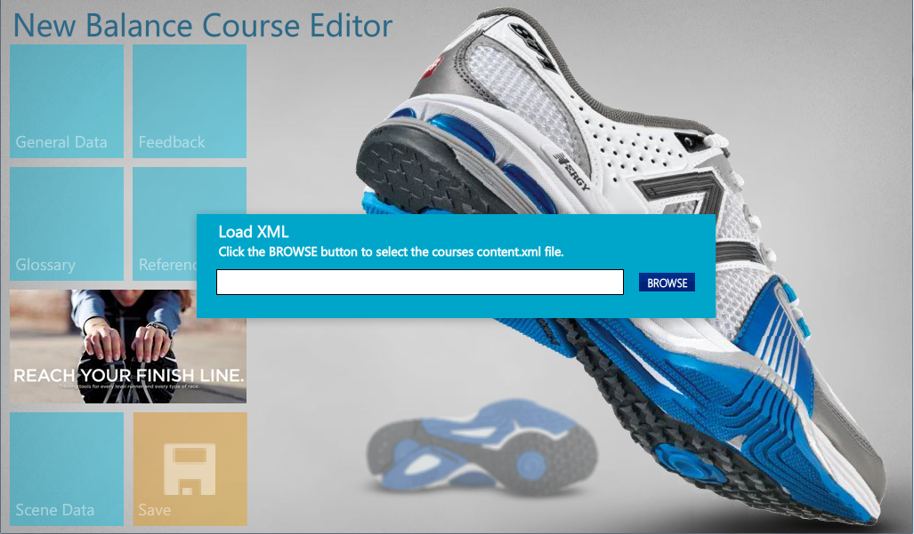

How to Start:

Open the “New Balance Course Editor.exe” locally on a computer. Changes are made to the file when the “Save” button is clicked.

Note. File names must be case sensitive.

Security Settings:

The course editor may require administrator privileges to open and save data. If you encounter problems opening the files please verify user privileges on the computer.

Editing Course Content:

The course editor ONLY edits the content.xml course file. Click the tiles to access the area you want to edit. Navigate to other areas by clicking on the tile. You can jump to any section at any time. Changes are preserved when jumping from one section to another.

Click the “Save” button to commit changes to a file. To view the changes in a course save the file as content.xml and run the content.swf. The content.swf will load the updated content.xml and display the changes. The content.xml must be in the same folder as the content.swf.

Editing General Data:

The section edits:

* Course Title
* Course Date
* Navigation Type
* Auto Scene complete
* Author

Description is provided in application.

Feedback Window Data:

The section edits the URL link in the feedback window. The text can be edited using Adobe Flash. Please follow the following format: mailto:....

Glossary Terms Data:

The section modifies deletes and adds glossary terms to the course. Click the “add” button to add a glossary term.

Reference Data:

The section edits the contents of the Reference Window. Reference can be added, removed and modified. Links can reference local and external links. A file link to a local file should reference the media folder. For example: media/examplefile.pdf.

Scene Data:

The section allows scene data to be edited. A scene is equal to a page in the course.

**Editing Lesson Titles:**

Lesson titles are indicated with an underline. A change to the title is reflected in the courses main menu.

**Editing Scene Data:**

To determine the page/scene that needs to be updated reference the storyboard for scene information. The scene number corresponds to the frame number in the storyboard.

**Audio File:**

This file is located in the media folder. Edit with any sound editing software.

**Caption Text:**

This is the text that appears in the closed captioning window. Changes can be made directly in this text field, however it is recommended to use the closedcaptioning_maker.fla to make edits. Copy and paste the outputted text from the closedcaptioning_maker.fla to the text fields.

**Caption Time:**

This section contains the times when the next line in the Closed Caption field is displayed. Changes can be made directly to this text field, however it is recommended to use the closedcaptioning_maker.fla. Copy and paste the outputted text from the closedcaptioning_maker.fla to the text fields.

Scene Text, Animation, Graphics:

Scene text, animations and graphics must be updated using Adobe Flash CS5.5 or greater. If you don’t have that version, use Adobe Flash CS5.5 to save the file to a lower version (Flash CS5 or Flash CS 4). No information will be lost when saving to an older version.

Text is very easy to update in Flash. Simply search (Edit > Find and Replace) for the text and double click on the locations listed. Double clicking on the location will open the area to edit. Edit the text like any word processer.

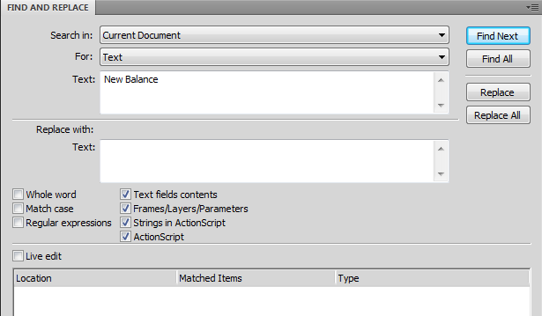

Any text changes will require the course to be re-published. File > Publish will create a new content.swf. Verify the changes by running the content.swf.

Updating question text:

Question text is contained in the content.xml. The course editor does not update the question text. Use any text editor (notepad) or XML editor (Dreamweaver) to edit the question/answer text. If special characters are needed to be added to the text, escape the string.

The correct answer is marked with a “1” in the answer node. If more than one answer is desired, set the selectiontype="multiple".

Note. Questions are randomized in the assessment. Locate the question by doing a search for the question text in the XML.

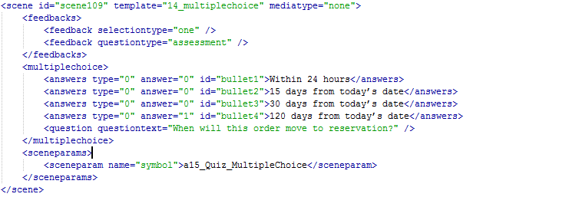

Using the Closed Captioning Maker.fl

Open the “closedcaptioning_maker.fla” in Adobe Flash Professional. Follow the instructions on the component movieclip.

Copy the text form the Flash Professional Output window and paste into the textfield in the course editor. Note. Only copy the contents between the “”. Do not copy the XML node data.

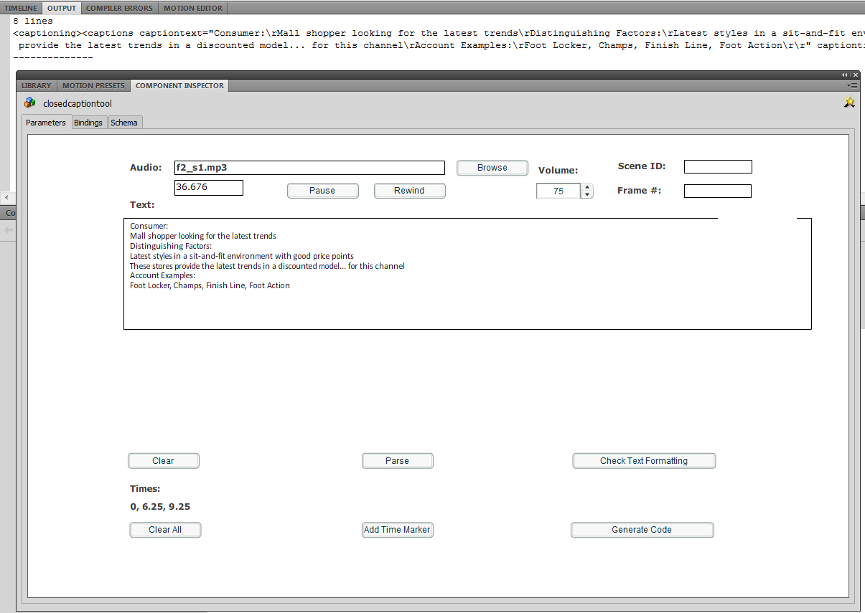

Packaging Course for LMS:

Copy the updated files from the working directory to the NB_Order_Process_SCORM.zip. This will overwrite the old content. If no new files were added to the course directory then upload the NB_Order_Process_SCORM.zip to the LMS.

If new media assets are added to the course (for example new local reference files), please modify the imsmanifest.xml by adding the new file reference node to the file. Once the change is made, upload the NB_Order_Process_SCORM.zip to the LMS.

Note. Make sure debug_DO_NOT_PLACE_ON_LMS.xml is not included in the SCORM package. Including the file will disable all tracking and put the course in debug mode.